Senior KG
Topics I will lean in February 2016-2017
English
Orals
- Learning three and four letter words

- ( spell it right)

Written:
- Sentence that rhymes ( writing book)

Dictation: Tiger,Elephant,Zebra,Horse, Sheep,Cat,Dog,Octopus, Whale,Shark

Sight words: Got, today, know, white, pick, black, some, drink

Mathematics
Orals:
- Revision of Addition and Subtraction , Time,Odd and Even numbers
Written:
- Greater than, smaller than and even to (<, >, =)

- Weight- Heavy and light

EVS:
1.Types of Wild animals and their features
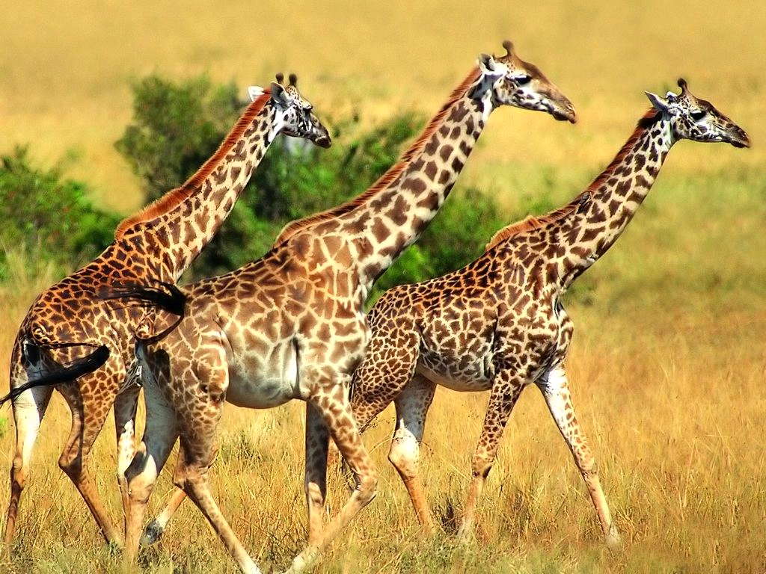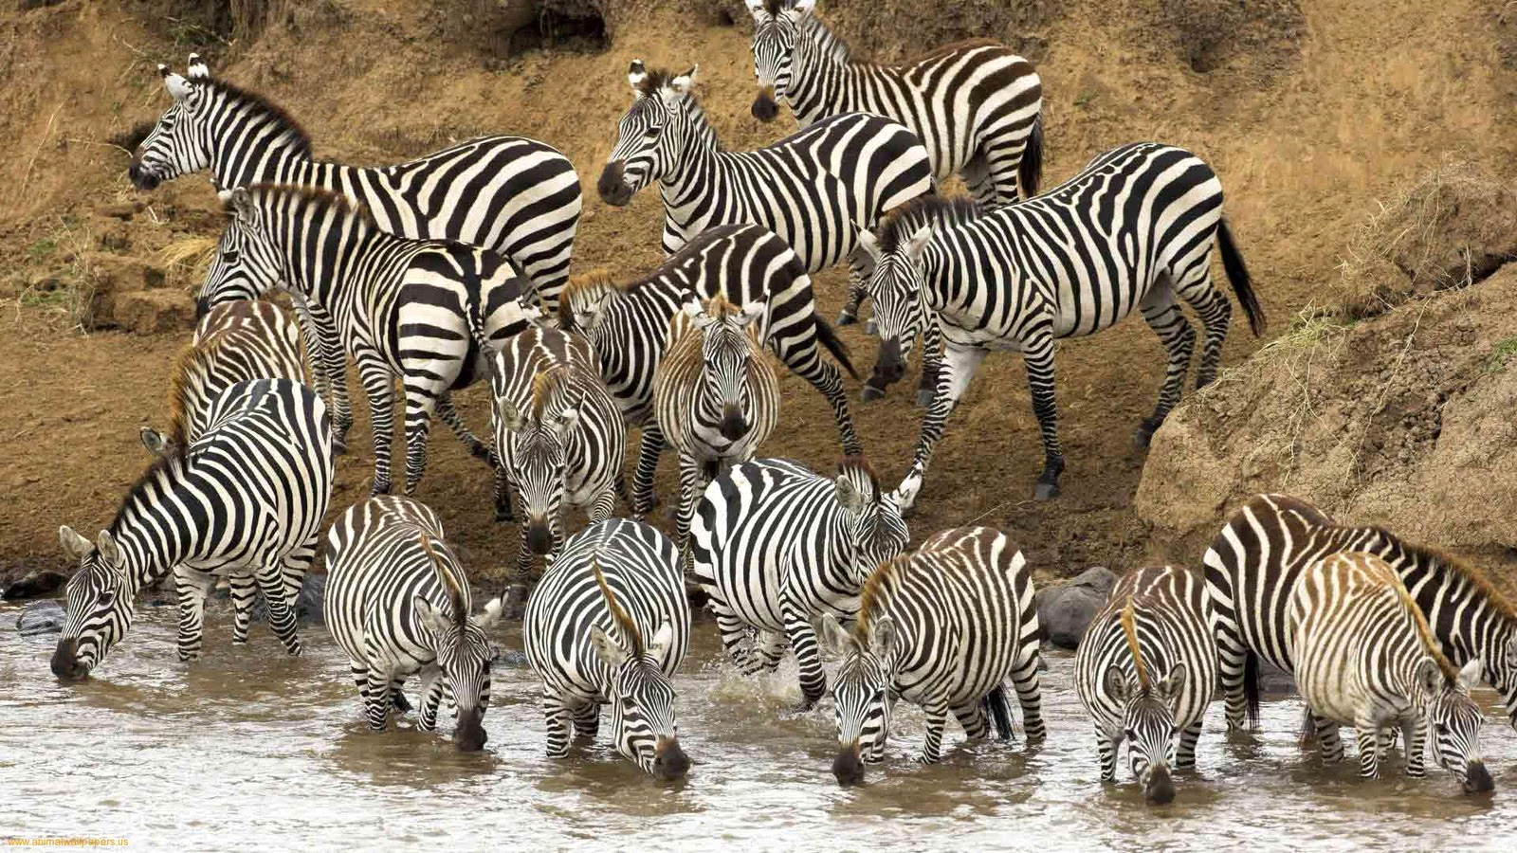

2. Different domestic animals and their specialities.
.
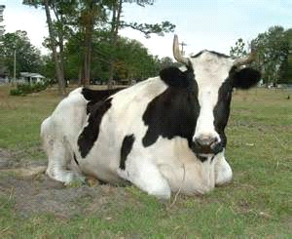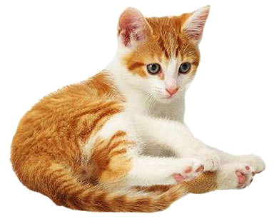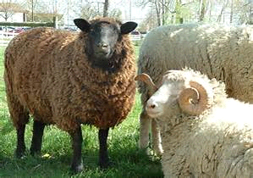

3. Names of aquatic animals and their features
. 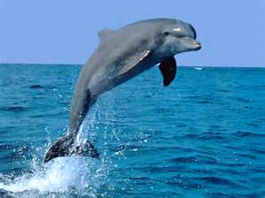 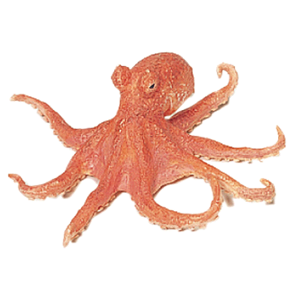 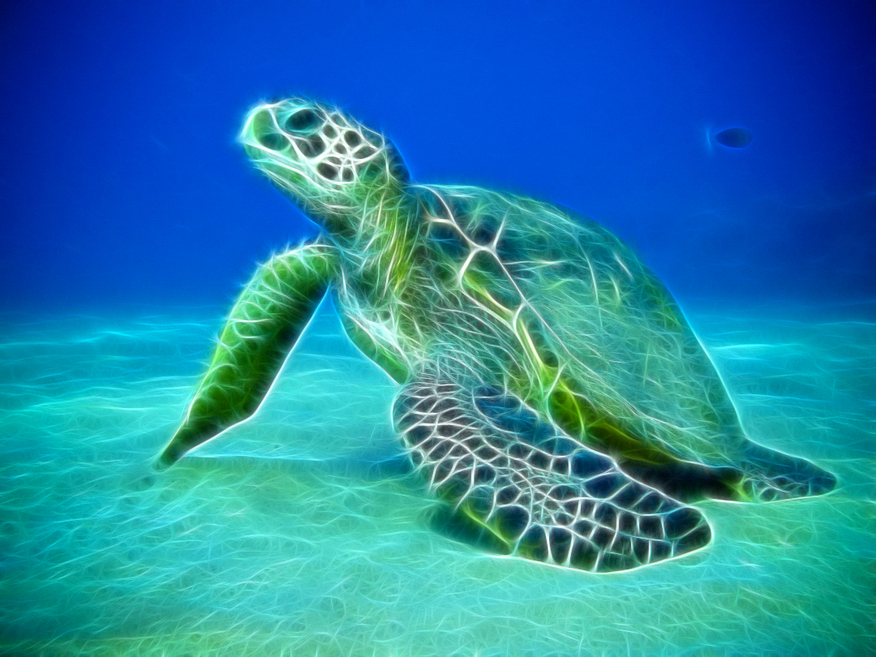

Gk:
1. Parts of plant which are utilized as vegetables
Root vegetables:
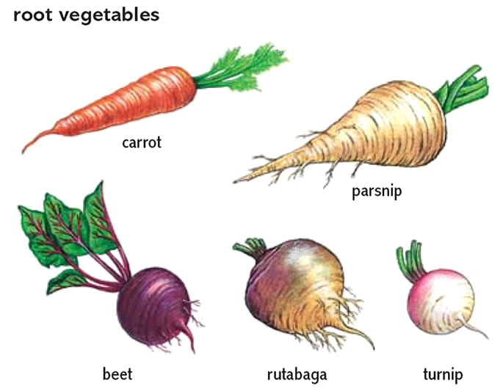
Stem vegetables:
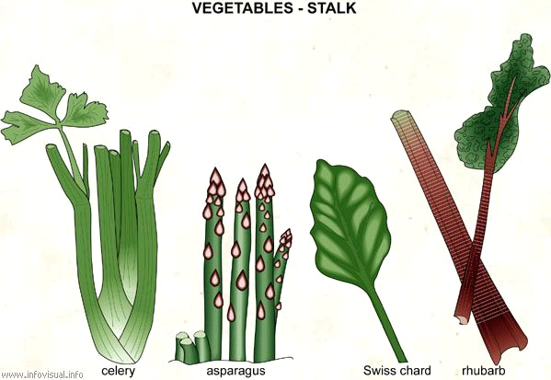

Leafy vegetables:

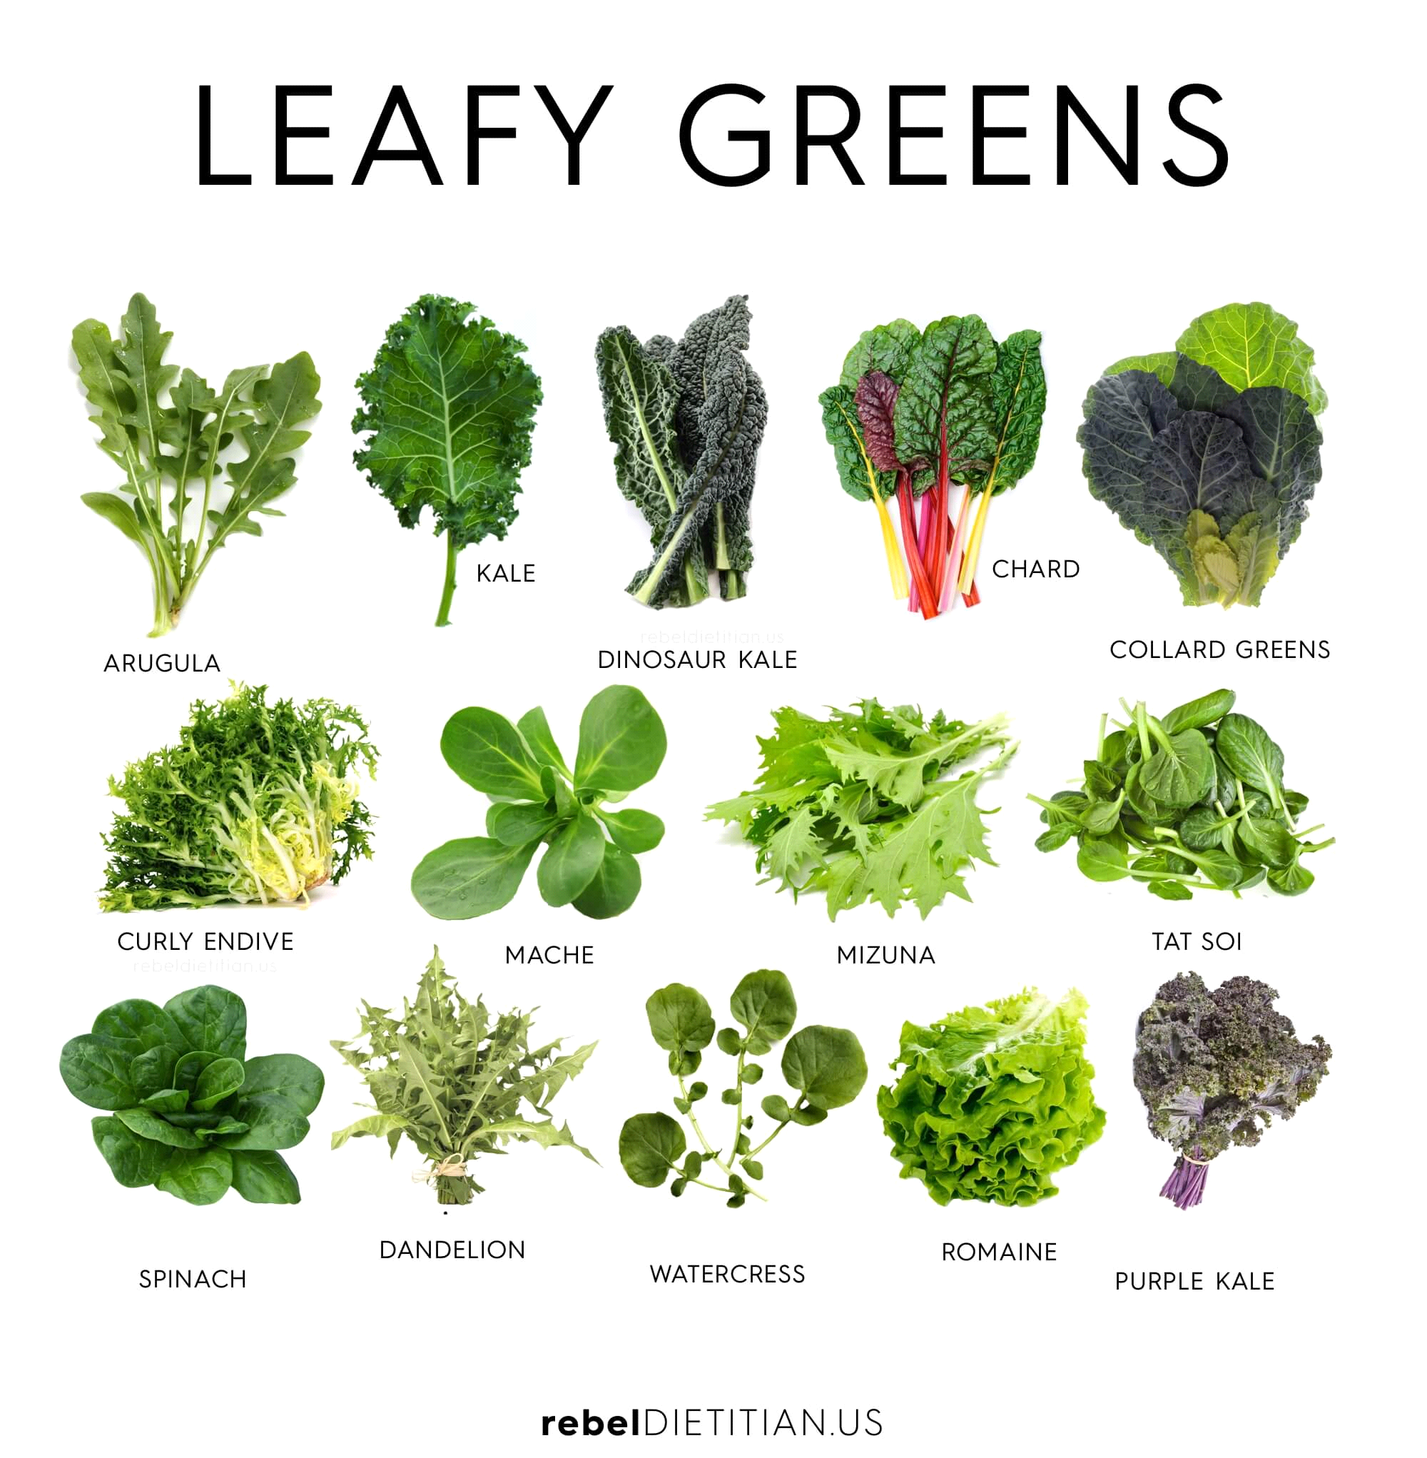
2.Food we get from animals:
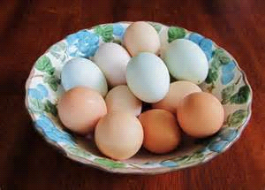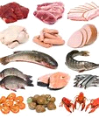
3.Importance of milk and milk products:
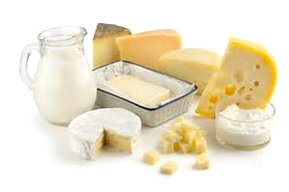

4.Liquid and solid food:
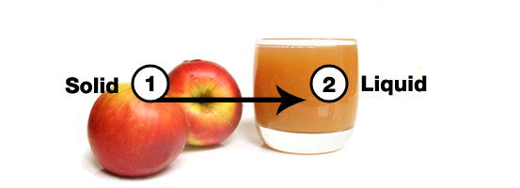

5.Junk and healthy food:

Rhymes:
An elephant goes like this and that
( pat knees)
He’s terribly big, ( hands up high)
And he’s terribly fat, ( hands out wide)
He has no fingers ( wriggle fingers)
And he has no toes ( touch toes)
But goodness gracious, what a nose!
( Hands make curling movement away from nose)

Five little sea creature
On the ocean floor
The turtle walked away
Now there are four.
Four little sea creature
Living in a sea
The octopus crept away
Now there are three.
Three little sea creature
Wondering what to do;
‘Good bye” said the whale
Now there are two.
Two little sea creature
Not having much fun
Off swam the sea horse
Now there is one.
One little fish
Sad and all alone
Back came the whale
Back came the sea horse
Back came the octopus
Back came the turtle
Then all five went home..

This is my little turtle ( make fist)
He lives alone in a shell.
He likes his little home.
He thinks It’s really swell.

He pokes out his head ( poke out thumb)
When he wants to eat.
Then he pulls it back in ( hide thumb in fist)
When he wants to sleep.

Once I saw an octopus
In the deep blue sea. ( point downward)

I called, Mr. octopus,
Won’t you swim with me?
( Cup hands around the mouth)

Then out came his tentacles,
So very long and straight( extend eight fingers)

One and two and three and four,
Five and six and seven and eight.( Count on fingers)

Creative work of the month: Animal craft by water bottle cap.

Activity of the month: Subject Expo.

