Syllabus for the month of February 2017
Jr KG
English
Recap of blends (Refer phonics book pg no. 48 to 58).
Introduction of digraphs (ch, sh, th, wh) (Refer phonics book pg no. 59- 65).
Introduction of Rhyming words (Refer phonics book pg no. 70- 73).
Sight words: They, This, Why, We, Who, Will

Rhymes
- Once I saw a little bird.
- I am a little parrot.
- Five little owls.
- Sunder, sunder mor dekho
Number work
Recap of Numbers (1- 100).
Recap of more and less than.
Recap of Missing Numbers (1 – 100)
Introduction of Time and Money.
EVS
Concept: Birds
(Recognition of birds and their physical features)
- Parrot 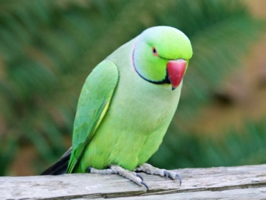
- Eagle

- Owl 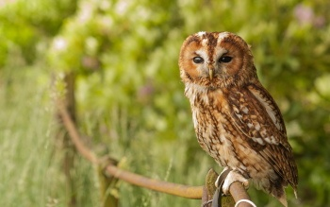
- Peacock 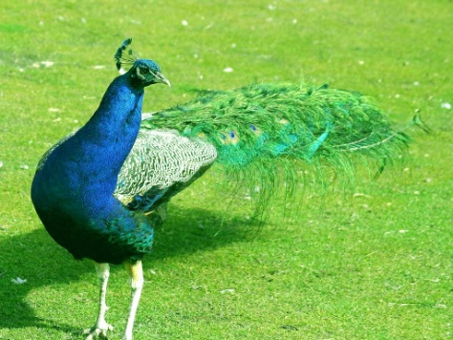

- Ostrich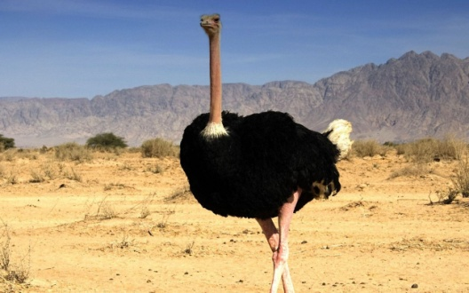

- Penguin

- Crow 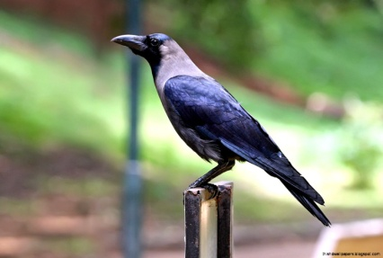

- Pigeon 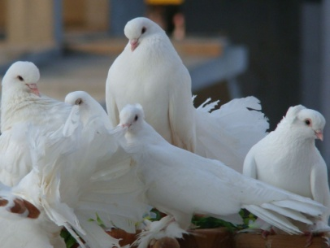

GK
- Introduction of Cereals – Rice, Wheat, Maize, Barley.
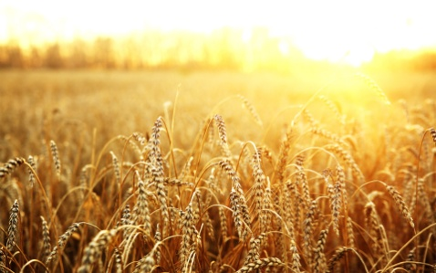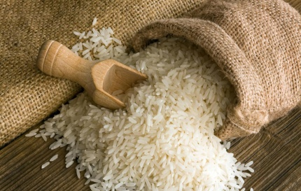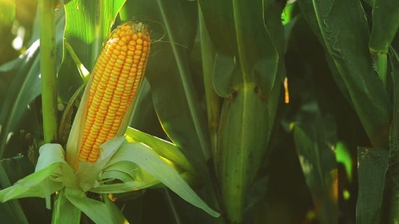

- Products made from Cereals – Flour, Roti, Bread, Bun.
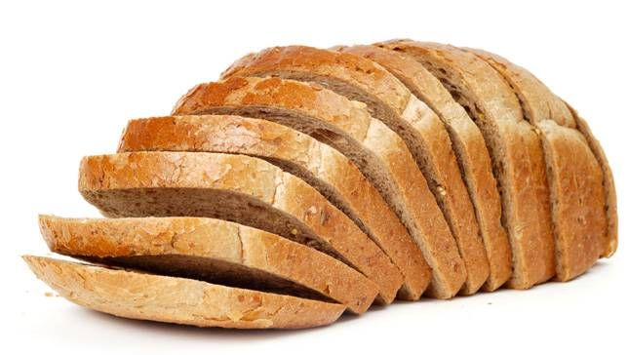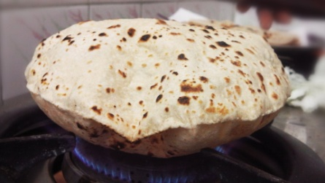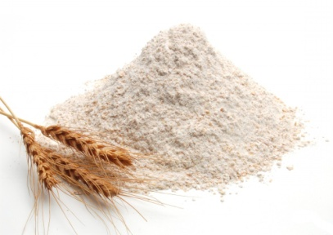

- Pulses – Rajma/ Kidney Beans, Gram Dal (Channa), Toor Dal, Green Gram dal (moong dal).
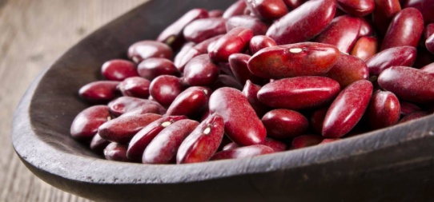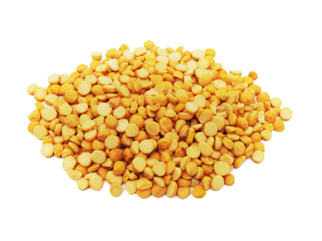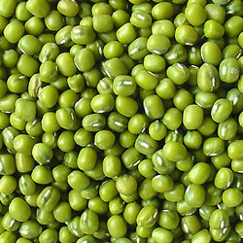

- Milk products- Butter, Curd, Paneer, Ghee, Lassi, Cheese.
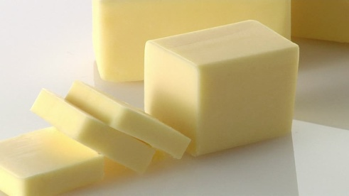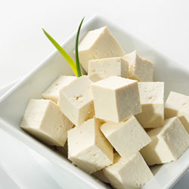

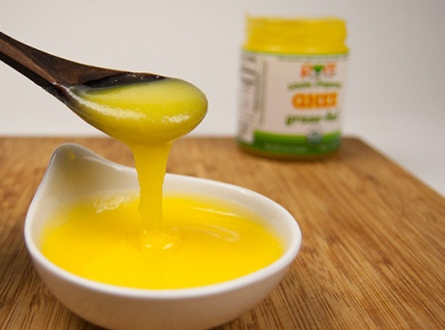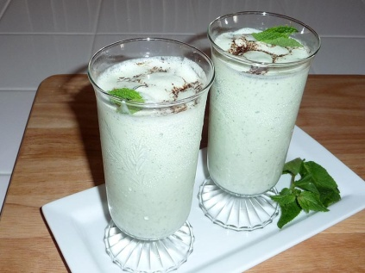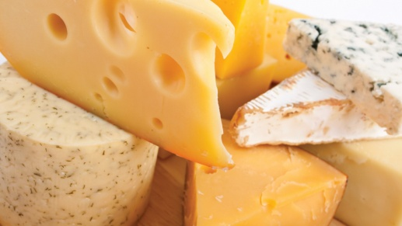
- Importance of Food.
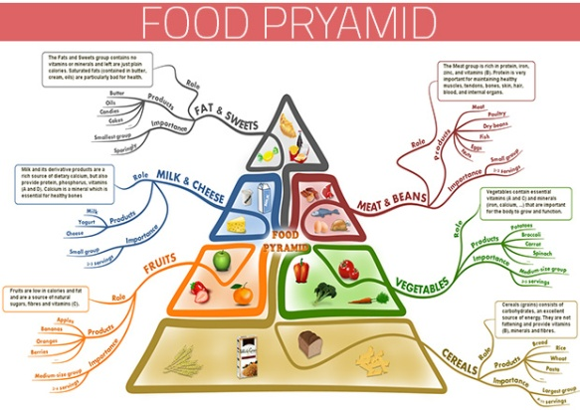

Hindi- Recap of
Recognition of
Kannada- Recap of
Recognition of
Creative work for the month:
- Corrugating

Rhymes
I am a little parrot  I am a little parrot  With feather all green  This is my tail  And this is my beak.  When I feel hungry  I look for the food  I love eating red chilies  And all type of fruits  I have pretty wings  And little feet too  I open my mouth  And say how do you do | Once I saw a little bird  Once I saw a little bird  Hop, hop, hop  So I said, little bird  Wont you stop, stop, stop  I was going to the window  To say how do you do?  But he shook the little tail  And away he flew
Five little owls  Five little owls on a dark, dark night  Five little owls are quite a sight.  Five little owls, are you keeping score?  One flies away and that leaves four  Four little owls as happy as can be  One flies away and that leaves three  Three little owls calling, “who, who, who”?  One flies away and that leaves two  Two little owls and that leaves one  One little own and we’ re almost done!  He flies away and leaves none! | Sunder sunder mor dekho  Sunder sunder mor dekho  Khubsurat roop dekho  Lambi neeli garden dekho  Sar par jaise taj dekho  Chhoti si ek chonch dekho  Aur chalta seena taan dekho  Intne sare rang hai jisme  Rang bi range pankh bhi hai  Panch phailakar jab morn ache  Lagta kitna sunder hai  Sunder sunder mor dekho  Khubsurat roop dekho

